Exercise No:1

Date:15.10.20

Aim: To print the calendar of a given month and year.

Program:

import calendar

year=int(input("enter year:"))

month=int(input("enter month:"))

if(year<10000 and year>999 and month<13 and month>0):

print(calendar.month(year,month))

else:

print("invalid input")

Link:

<http://103.53.53.18/mod/vpl/forms/edit.php?id=229&userid=1702>

Output:

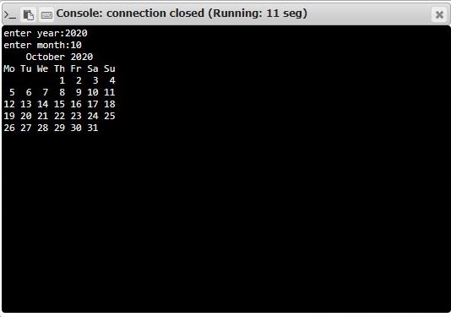

Result:

Thus the program has been successfully executed and the output is verified.